# Reduction of 15IDD USAXS/pinSAXS data with Nika

Nika version: 1.52

## Introduction

This is step by step procedure for data reduction of pinSAXS data from 15IDD combined USAXS/SAXS instrument. This applies to data collected in 2011-03 APS cycle. This DOES NOT apply to 2011-02 cycle, when data were saved ONLY in Tiff file format. Some of the tools can be used, but it is not so straight forward. You may want to contact me for help with reduction of data from 2011-02 cycle.

## Necessary pre-requisite

You need to have USAXS data and reduce them first. The customized settings of Nika package will look up the parameters from USAXS data. Further, you need to have installed Irena package so you can merge the data together.

## Procedure

1. Nika configuration

Select from Nika “SAS 2D” > “Instrument configuration” > “15IDD SAXS”

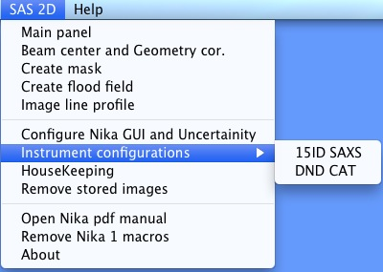

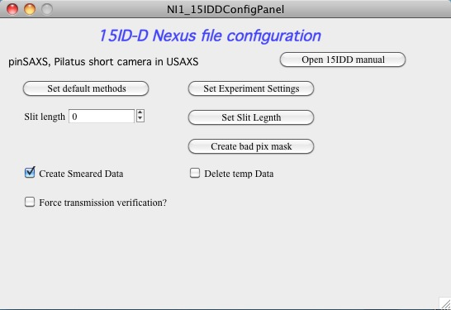

You should be able to open this manual when you push button “Open 15IDD manual”. If this is not available onyrou computer, contact me.

## Basic Configuration

Use button “Set default methods” which will set part of the parameters, which is independent on the beamline setup. This will force dialog in which you need to find your area detector data. NOTE: the folder with your area detector data was named same as your spec file.

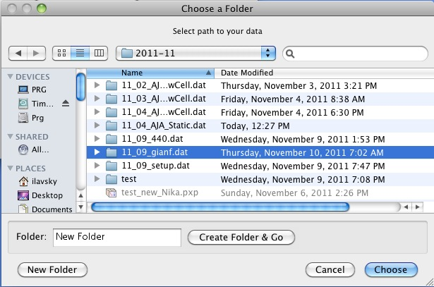

This will set the basic methods to be used…

See following images:

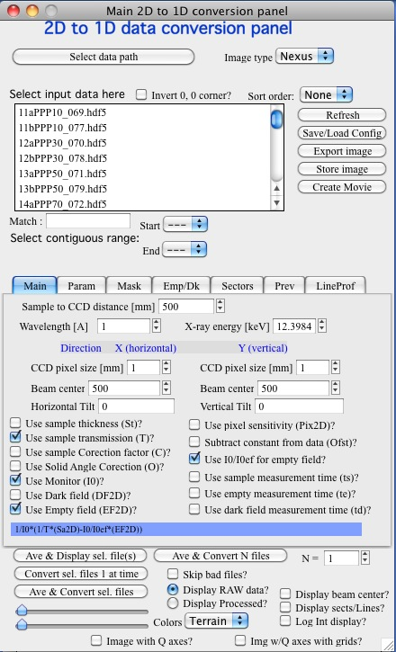 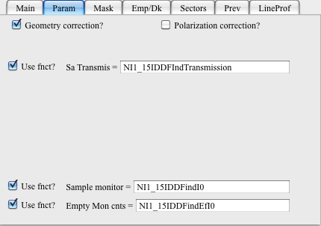

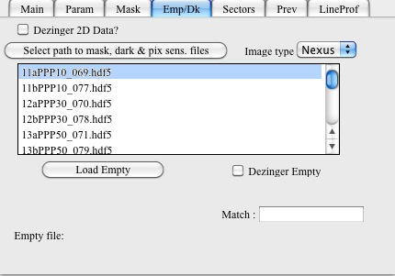 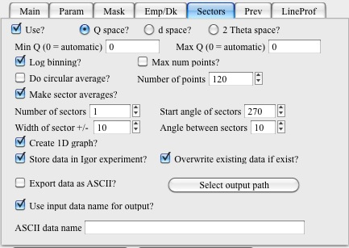

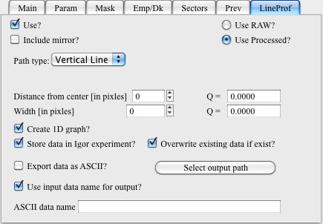

Now select ANY image file and use button “Ave & Display sel. File(s)” on main panel to load it in. Really does not matter which, just from the right folder with the data. The assumption here is, that data collected while using one spec file will have same metadata.

Note two windows, one is image and the other is metadata which were included in that image:

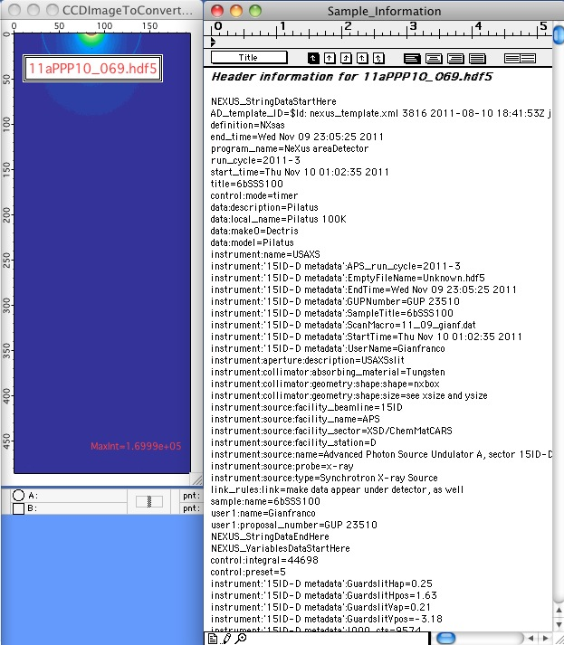

The image is kind of more informative, if you select “Log Int. display” at the bottom of main Nika panel.

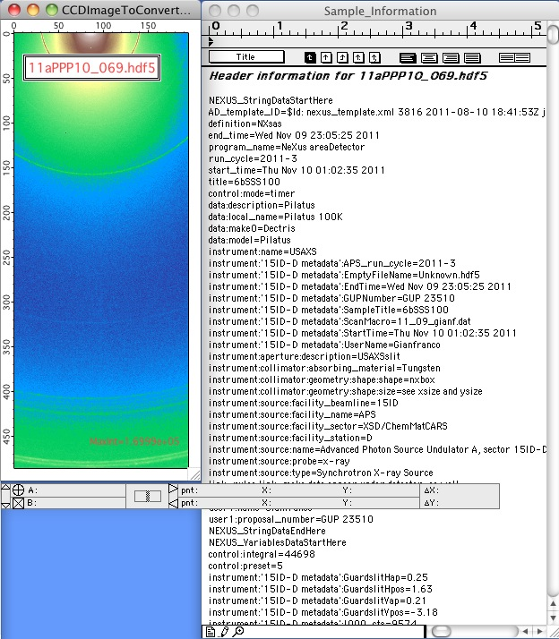

Now use button “Set Experiment Settings” from the “15ID-D Nexus File Configuration” to load in default values stored in the wave note.

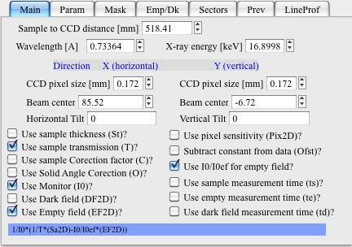

Some of these are guaranteed to be correct (wavelength, pixel size) and some are likely just close (beam center, distance). We will refine those next.

## Beam center/distance fine tuning

Stored beam center and distance between sample and area detector are likely close, but not perfect. We need to refine them next using measurement of Ag Behenate. Note, that you may have more than one Ag Behenate measurement if you had multiple “batches” of samples collected. These are likely close together, so you may choose to use only one setting for all samples, but correct procedure is to optimize Beam center/distance for every batch independently.

Select “Beam center and Geometry cor.” From “SAS 2D” menu.

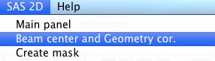

Find appropriate Ag Behenate data set and hit “Make Image”, select “Log Image?” checkbox in the middle left of the panel:

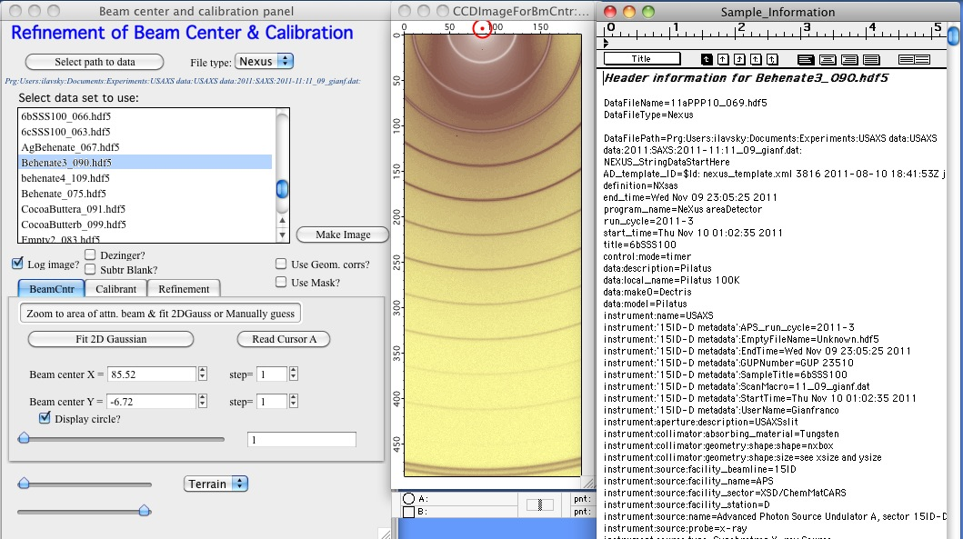

Note the red dot and circle at the top is position of the beam center stored in the metadata by beamline scientist.

Select tab “Calibrant” and you should see:

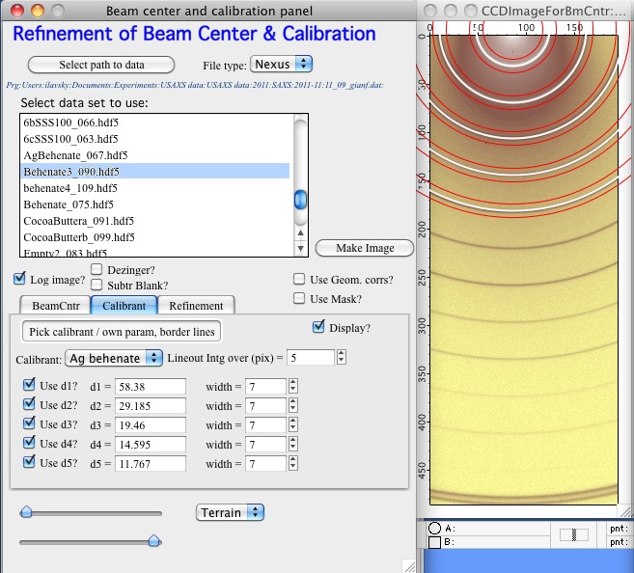

This shows that Ag Behenate is predefined as calibrant. The grey lines of Ag Behenate should be between the two red lines around the white line. The white line is estimate of position of the diffraction lines using the distance and beam center from the metadata, two red lines indicate how wide will Nika search for the peak positions. This should be more or less correct. If higher orders are too weak, you may choose to uncheck higher orders of the diffractions here (d5, d4 etc.).

Select tab “Refinement” and select “Refine beam center” and “Refine Sa-Det distance”. Run first the refinement (“Run refinement” button) with “Gauss” selected as “Peak shape function”. If the fitting to peak profiles starts failing, select “Gausswithslopedback”. Gauss should be more stable, but when background is significant, the “Gausswithslopedback” may be necessary.

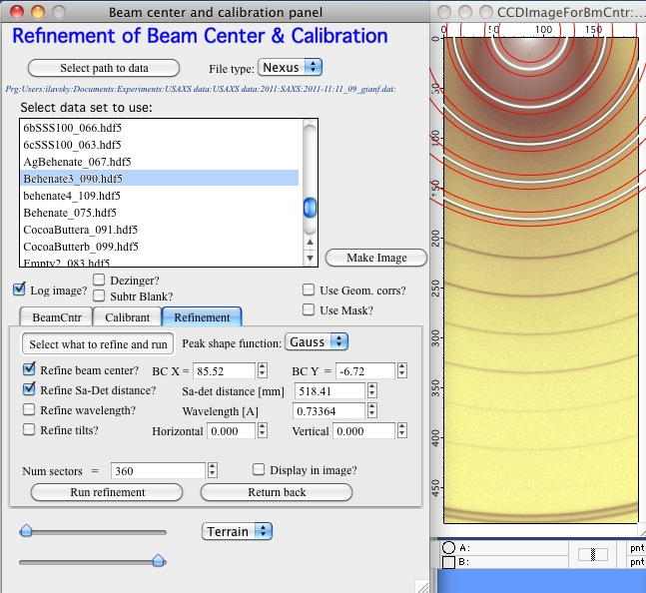

After fitting, history are will contain message with achieved chi-squared. Now select checkbox “Refine tilts” and run again. The chi-squared should improve somehow, there are likely tilts (about 0.5 deg horizontal, 4.5 deg vertical in my case):

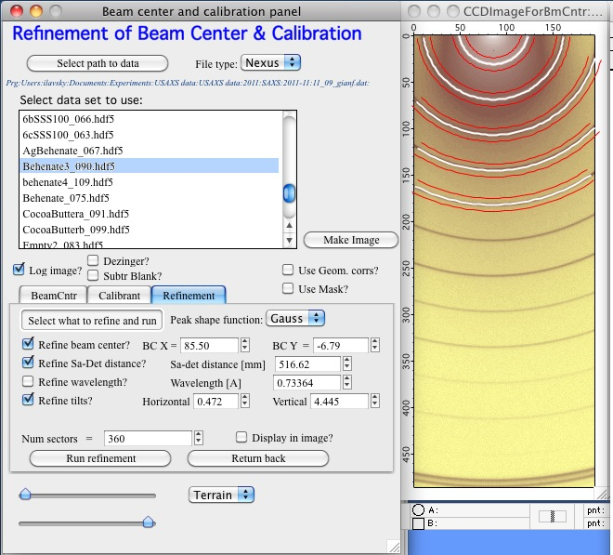

This is done… You now have the best geometry parameters you can have for the batch of data the AG Behenate file is associated with. Close the panel, Sample_Information notebook, and image.

## Further configuration

Set the slit length by selecting “Set Slit Length” button and selecting any USAXS data from the spec file with the same name as your 2D data folder (slit length is same for all data in one USAXS geometry, therefore nearly reliably for all samples in one USAXS spec file).

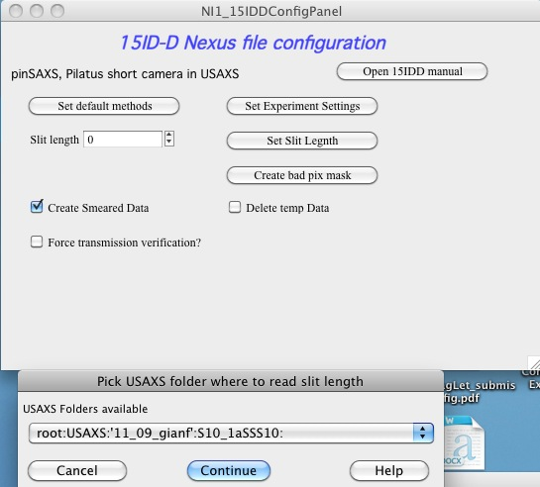

Slit length should be now set to sensible number (around 0.02 – 0.04 most likely).

If you want to use Mask to remove two bad pixels on the Pilatus detector, push button “Create bad pix mask”. This will create the mask and select the “Use Mask?” on the main panel:

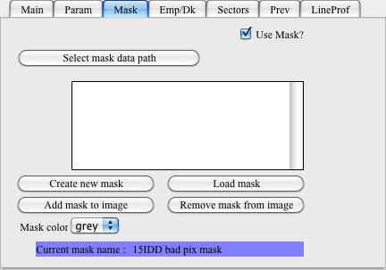

Note, this will overwrite any existing mask in the Igor experiment and so if you want to use other mask (if necessary), then you need to create your own mask and mask yourself points [86,17] and [58,112] as part of that mask.

## Select what data to use…

OK, here comes the fun.

1. Area detector data can be reduced as pinhole collimated by doing sector average. Predefined sector is +/-10 degrees around 270 degrees direction (that is vertically down from beam center in Nika notation). These data use as much high-q data as possible reducing the noise, but they are noisy at low-q as number of bins used there is small. They are by default log-binned in Q, further reducing the number of points and therefore noise. NOTE: if you have diffraction lines and want to get high-q resolution, you need to select “Max num points” on the “Sectors” tab to avoid log-binning in q.

2. Area detector data can also be reduced in “Slit smeared” configuration by using lineProf tool around the 270 degrees direction over width of about the slit length. This uses lot more points at low-q but much less points at high q. This tool also cannot be used to bin q scale logarithmically.

See the difference in the images when you add the lines using “Display sects/Lines?” on the main panel.

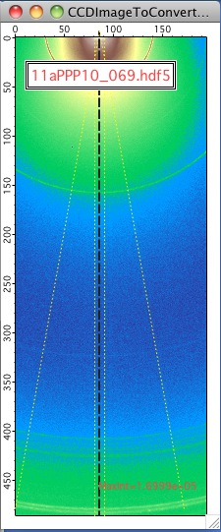

The slit smeared data can be merged with USAXS SMR data directly, the pinhole data can be merged with the desmeared data only…

So here comes the trick. If you choose “Create Smeared data” checkbox on the 15ID-D Nexus file configuration panel, Nika will generate both of the data listed above and merge them together by using the smeared data at q values smaller than 3*slit length and pinhole data at q values higher than 3*slit length. These data should have the best of both Worlds here: smeared data at low q values to enable merging with SMR USAXS data and lowest noise at high q…

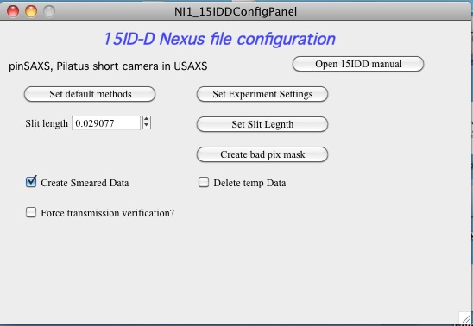

If you select “Delete temp Data” checkbox, the sector and line profile data will be deleted, reducing amount of data created and therefore clutter. On the other hand, if you want to see differences, you can uncheck it and look at the different data created.

“Force Transmission verification” – since not all samples are homogeneous and USAXS beam size is typically larger than pinSAXS one, the transmission for USAXS and pinSAXS MAY be different. However, we measure ONLY USAXS transmission… To enable user to modify (aka: try, fudge,…) modification of the transmission, here is checkbox which will force user dialog for transmission for each sample when the sample is being reduced. The following window will then appear for each sample:

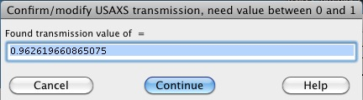

Use when needed. Carefully…

## This should end the configuration part.

## Data reduction part:

Here we take advantage of the fact, that Nika can look up various parameters from USAXS data reduction and therefore can be helpful.

Select file you want to reduce. Then hit “Convert sel. Files 1 at time” button on main panel.

If Nika finds wrong empty (or no empty at all) it will put out dialog:

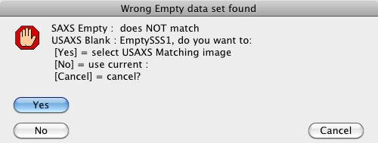

Nika is here using name of the USAXS blank name and compares with the empty 2D file loaded. It cleans up extension and order number, also can remove _XYZs which is used by some users to indicate different exposure times. Nika will also check, how many similarly named images are there in the current folder and put out the dialog, if the selection is not unique.

You choices are to load proper image, keep current or abort in case you are really confused by now.

Choose “Yes” to load proper empty file and dialog is presented:

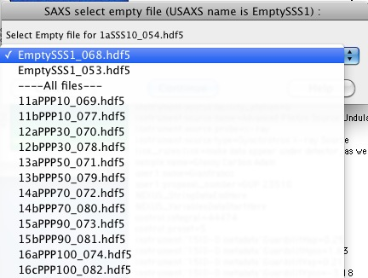

Note, that the most likely 2D data sets, matching the USAXS blank name are presented at the top. Just to make sure, all 2D data sets are presented below.

Select the right 2D data for empty and it is loaded.

Note: if you do not get dialog for empty data set, it means that Nika code has decided that the current empty name matches sufficiently the name of the USAXS blank. There is no guarantee that this is correct, but I think it would become very annoying to add more dialogs here.

Note that in the history area are records of what was found and used:

*Loaded following wave: root:Packages:NexusImport:'11aPPP10_069.hdf5':data  
Loaded file 11aPPP10_069.hdf5  
For sample : 11aPPP10_069.hdf5 has been found USAXS transmission = 0.93608 in folder : root:USAXS:'11_09_gianf':S85_11aPPP10:*

This enables to process large number of data sets quickly and efficiently, as the code is keeping empty file selection under control and is getting transmissions automatically.

If the USAXS data cannot be found, the code will present dialog to user asking for transmission values.

Here are some data which users measured and which were processed by suing this code:

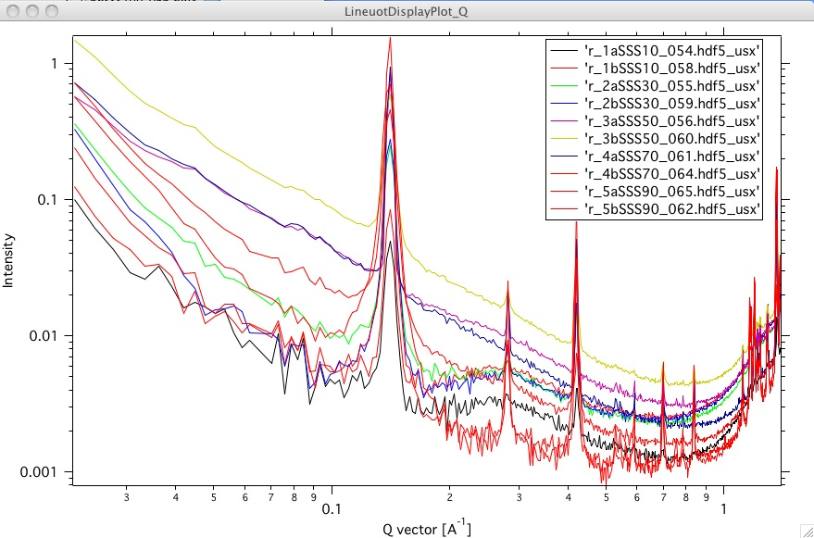

## Merging the data together

To merge the data together we can use the _usx data from PinSAXS and SMR data from USAXS, we can use the “Data manipulation I” from Irena.

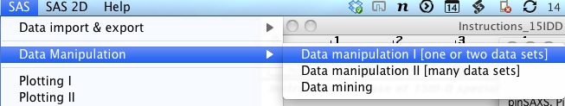

Select “Indra 2 data” for First data set and “QRS” for second data set, select the same sample measured and “Add data and Graph” button.

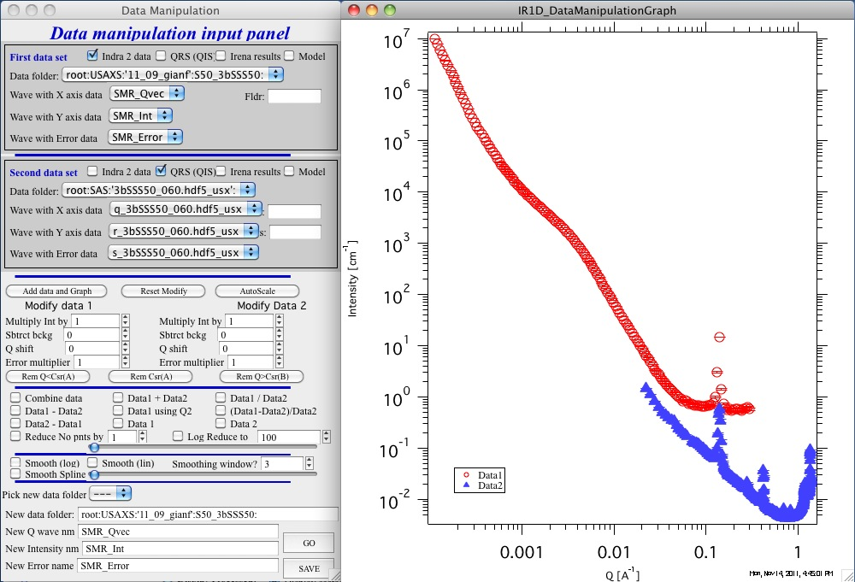

Zoom to range where data overlap and subtract background from data set 1 (Modify data 1 area) to match the slope of the curves in the overlap region:

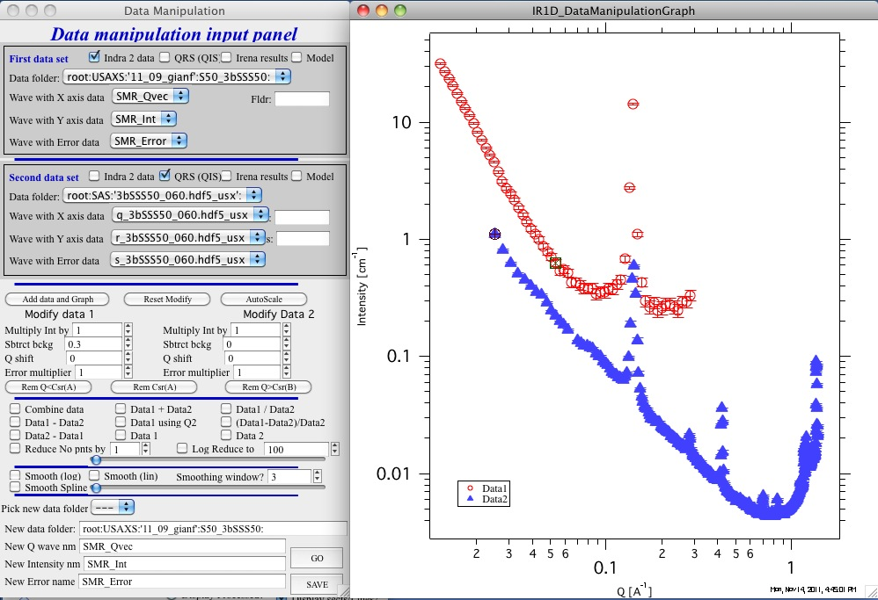

Do not over subtract or the slopes will not match. Select with cursors are where the data overlap well and use “AutoScale” button to scale the data together:

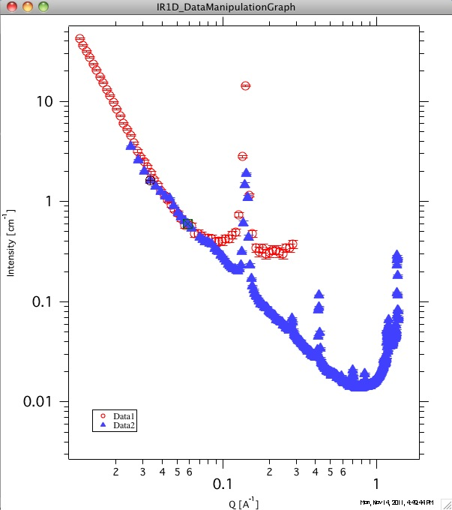

Now you should remove the pinSAXS data for first few points (3-5 points typically) where there are edge effects and other artifacts in pinSAXS data. Use rounded cursor and “Rem Q<CSR(A)” button. Remove USAXS data at high Q where the noise or background are too large using rectangular cursor and “Rem Q>Csr(B)” button. Make sure the cursors are on the right data set.

Then select “Combine data” as processing method and hit button “Go”.

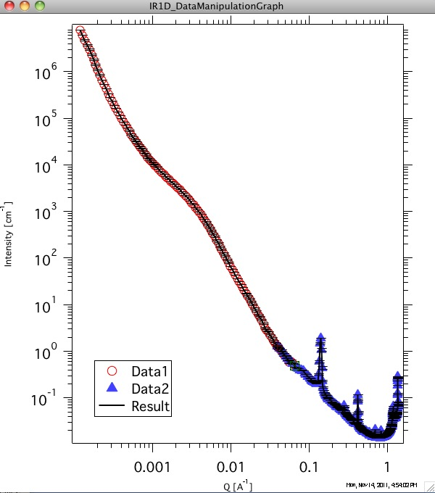

When happy with the result modify the name of the “New data folder” (may be add behind the name: “_comb”) and save the data.

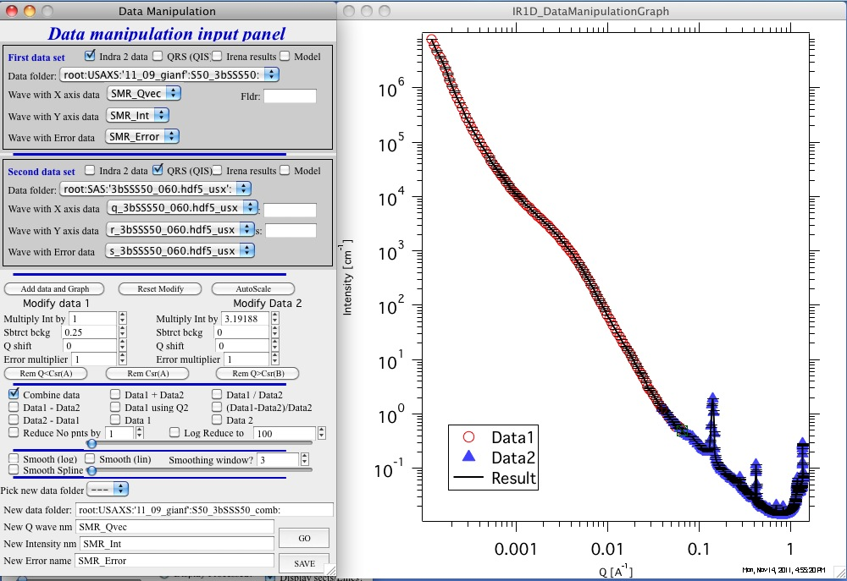

New data were created. These data have absolute calibration from USAXS instrument. They also are still slit-smeared with the original slit length and can be desmeared or modeled by Irena as slit smeared:

